# 1. Total Customers
SELECT COUNT(*) AS total_customer
FROM creditcard;
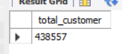
#2. Total Annual Income
SELECT sum(AMT_INCOME_TOTAL) AS total_Annual_Income
FROM creditcard;
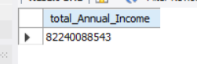
#3. Average Annual Income
SELECT AVG(AMT_INCOME_TOTAL) AS Average_Annual_Income
FROM creditcard;
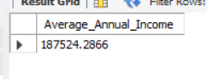
#4. Average Customer Age
SELECT AVG(Age) AS avg_Age
FROM creditcard;
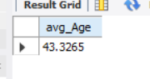
#5. Average Employment Years
SELECT AVG(Employment_Years) AS avg_Employment_Years
FROM creditcard;
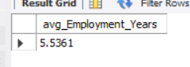
#6. Car Ownership Rate (%)
SELECT ROUND(SUM(CASE WHEN FLAG_OWN_CAR = 'Y' THEN 1 ELSE 0 END) * 100.0 / COUNT(*), 2) AS Car_Ownership_Rate
FROM creditcard;
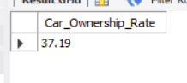
#7. Real Estate Ownership Rate (%)
SELECT round(sum(CASE WHEN FLAG_OWN_REALTY = 'Y' THEN 1 ELSE 0 END) * 100.0 / COUNT(*), 2) AS realty_own_Rate
FROM creditcard;
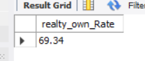
#8. Average Number of Children
SELECT round(avg(CNT_CHILDREN), 2) AS avg_Children
FROM creditcard;
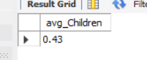
#9. Average Family Members
SELECT avg(CNT_FAM_MEMBERS) AS avg_Family_Members
FROM creditcard;
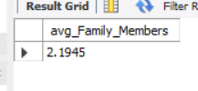
#10. Email Availability Rate (%)
SELECT round(sum(CASE WHEN FLAG_EMAIL = 'Y' THEN 1 ELSE 0 END) * 100.0/ COUNT(*), 2)AS Email_rate
FROM creditcard;
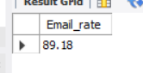
#11. What is the gender distribution of customers?
SELECT CODE_GENDER, COUNT(*) AS count_customer
FROM creditcard
GROUP BY CODE_GENDER;
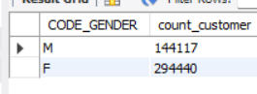
#12. Which age group has the highest number of customers?
SELECT Age_Group, COUNT(*) AS highest_customer
FROM creditcard
GROUP BY Age_Group
ORDER BY highest_customer DESC;
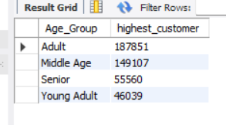
#13. Which family status has the highest number of customers?
SELECT NAME_FAMILY_STATUS, COUNT(*) AS highest_customer
FROM creditcard
GROUP BY NAME_FAMILY_STATUS
ORDER BY highest_customer DESC;
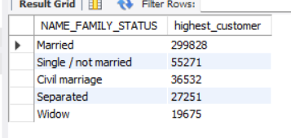
#14. Which housing type has the highest number of customers?
SELECT NAME_HOUSING_TYPE, COUNT(*) AS high_customer
FROM creditcard
GROUP BY NAME_HOUSING_TYPE
ORDER BY high_customer DESC;
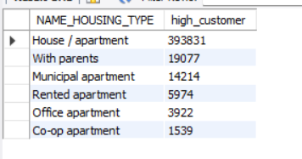
#15. Which income type has the highest number of customers?
SELECT NAME_INCOME_TYPE, COUNT(*) AS high_customer
FROM creditcard
GROUP BY NAME_INCOME_TYPE
ORDER BY high_customer DESC;
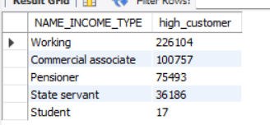
#16. Which income type has the highest average annual income?
SELECT NAME_INCOME_TYPE, avg(AMT_INCOME_TOTAL) AS avg_annual_income
FROM creditcard
GROUP BY NAME_INCOME_TYPE
ORDER BY avg_annual_income DESC;
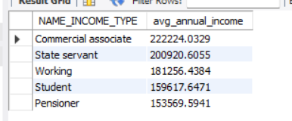
#17. Which occupation has the highest average annual income?
SELECT OCCUPATION_TYPE, AVG(AMT_INCOME_TOTAL) AS avg_annual_income
FROM creditcard
GROUP BY OCCUPATION_TYPE
ORDER BY avg_annual_income DESC;
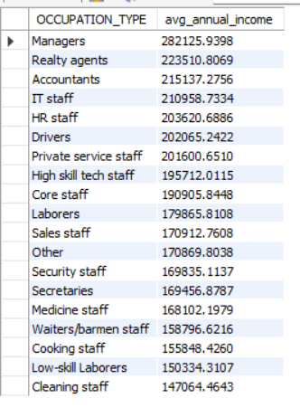
#18. Which education level has the highest average annual income?
SELECT NAME_EDUCATION_TYPE, AVG(AMT_INCOME_TOTAL) AS avg_annual_income
FROM creditcard
GROUP BY NAME_EDUCATION_TYPE
ORDER BY avg_annual_income DESC;
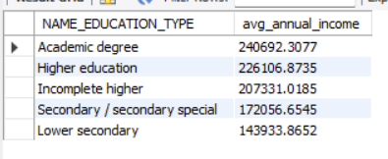
#19. How does annual income vary across age groups?
SELECT Age_Group, ROUND(AVG(AMT_INCOME_TOTAL),2) AS avg_annual_income
FROM creditcard
GROUP BY Age_Group
ORDER BY avg_annual_income DESC;
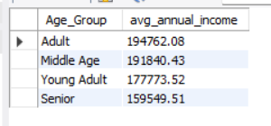
#20. How does annual income vary by employment years?
SELECT Employment_Years, ROUND(AVG(AMT_INCOME_TOTAL), 2) AS avg_annual_income
FROM creditcard
GROUP BY Employment_Years
ORDER BY avg_annual_income DESC;
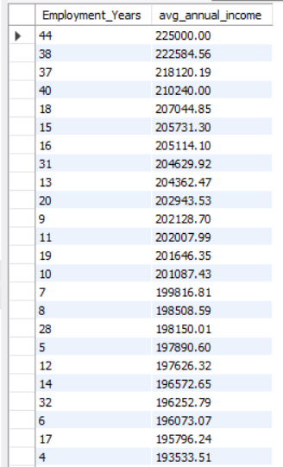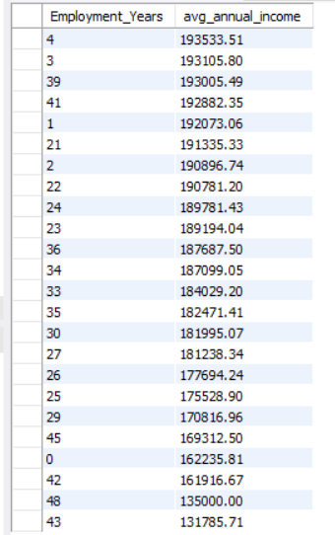
#21. Which occupation is most common among customers?
SELECT OCCUPATION_TYPE, COUNT(*) AS count_customer
FROM creditcard
GROUP BY OCCUPATION_TYPE
ORDER BY count_customer DESC
LIMIT 1;

#22. Which education level is most common among customers?
SELECT NAME_EDUCATION_TYPE, COUNT(*) AS common_customer
FROM creditcard
GROUP BY NAME_EDUCATION_TYPE
ORDER BY common_customer DESC
LIMIT 1;
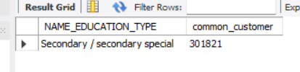
#23. What is the relationship between education level and occupation?
SELECT NAME_EDUCATION_TYPE, OCCUPATION_TYPE, COUNT(*) AS total_occupation
FROM creditcard
GROUP BY NAME_EDUCATION_TYPE , OCCUPATION_TYPE;
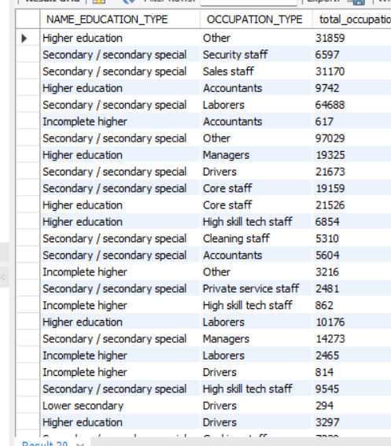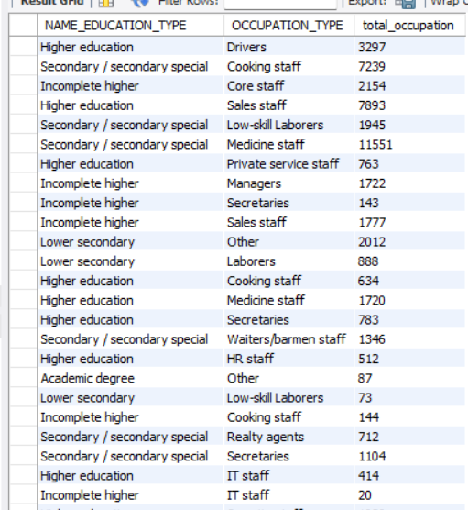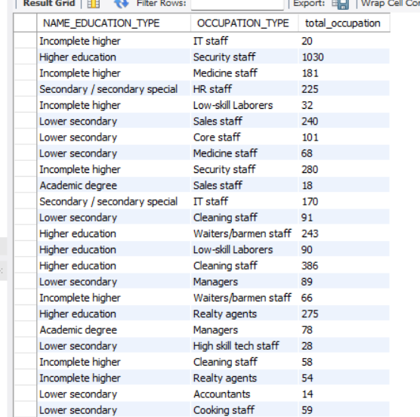

#24. Which occupation has the highest car ownership rate?
SELECT OCCUPATION_TYPE, ROUND(SUM(CASE WHEN FLAG_OWN_CAR = 'Y' THEN 1 ELSE 0 END)*100.0 / COUNT(*), 2) AS highest_car_ownership_rate
FROM creditcard
GROUP BY OCCUPATION_TYPE
ORDER BY highest_car_ownership_rate DESC;
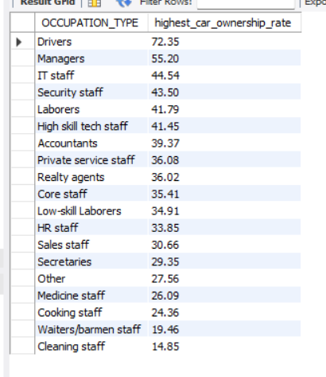
#25. Which education level has the highest real estate ownership rate?
SELECT NAME_EDUCATION_TYPE, ROUND(SUM(CASE WHEN FLAG_OWN_REALTY = 'Y' THEN 1 ELSE 0 END) * 100.0 / COUNT(*), 2) AS highest_real_estate_ownership_rate
FROM creditcard
GROUP BY NAME_EDUCATION_TYPE
ORDER BY highest_real_estate_ownership_rate DESC;

#26. Which housing type has the highest real estate ownership rate?
SELECT NAME_HOUSING_TYPE, ROUND(SUM(CASE WHEN FLAG_OWN_REALTY = 'Y' THEN 1 ELSE 0 END) * 100.0 / COUNT(*),2) AS highest_real_estate_ownership_rate
FROM creditcard
GROUP BY NAME_HOUSING_TYPE
ORDER BY highest_real_estate_ownership_rate DESC;
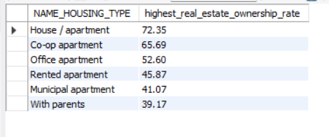
#27. Which family status has the highest average number of children?
SELECT NAME_FAMILY_STATUS, ROUND(AVG(CNT_CHILDREN),2) as avg_children
FROM creditcard
GROUP BY NAME_FAMILY_STATUS
ORDER BY avg_children DESC;
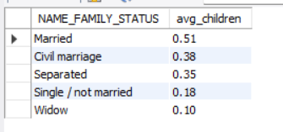
#28. How does family size vary across family status?
SELECT NAME_FAMILY_STATUS, ROUND(AVG(CNT_FAM_MEMBERS),2) AS family_size
FROM creditcard
GROUP BY NAME_FAMILY_STATUS;
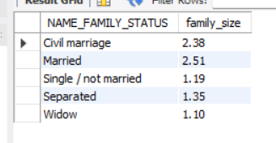
29. Which occupation has the highest email availability?
SELECT OCCUPATION_TYPE, ROUND(SUM(CASE WHEN FLAG_EMAIL = 'Y' THEN 1 ELSE 0 END ) * 100.0 / COUNT(*) , 2) AS highest_email
FROM creditcard
GROUP BY OCCUPATION_TYPE
ORDER BY highest_email DESC;
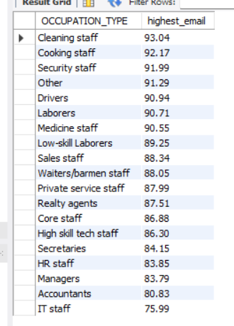
#30. Which income type has the highest work phone availability?
SELECT NAME_INCOME_TYPE, ROUND(SUM(CASE WHEN `FLAG_WORK_PHONE_(YES/NO)` = 'Y' THEN 1 ELSE 0 END ) * 100.0 / COUNT(*) , 2) AS work_phone_availability_rate
FROM creditcard
GROUP BY NAME_INCOME_TYPE
ORDER BY COUNT_WORK_PHONE DESC;
